|  |  |  |  |
| --- | --- | --- | --- |
| **Group No.** | **Group Members** | | |
|  | **ID** | **Name** |
| **3** | 1. | **20-42195-1** | **LEO, NAFINUR** |
| 2. | **20-42752-1** | **HOWLADER, MD. SHAKIB** |
| 3. | **20-42794-1** | **FAHIM, SHAH NAWAJ** |
| 4. | **20-42853-1** | **RAHMAN, HASIBUR** |
| 5. | **20-42870-1** | **HASSAN, MD. ALIF** |
|

**Laboratory Experiment Report**

Electronic Devices Laboratory

Semester: Spring 2021-22

|  |  |  |
| --- | --- | --- |
| **Experiment No.:**  **5** |  | |
| **Experiment Title: Study of Transistor Characteristics in Common Emitter Amplifier.** |  | |
| **Date of Experiment: 20-02-2022**  **Date of Report Submission: 16-03-2022** | |  |

**Marking Rubrics for Laboratory Report (to be filled by Faculty)**

|  |  |  |  |  |
| --- | --- | --- | --- | --- |
| **Objectives** | **Unsatisfactory (1)** | **Good (2-3)** | **Excellent (4-5)** | **Marks** |
| **Theory** | The relevant theories are not being described properly. | Part of the relevant theories are described with proper mathematical expression and circuit diagrams (if any) | All the relevant theories are included with proper descriptions, mathematical expressions and circuit diagrams. (if any) |  |
| **Simulation circuits & Results** | Simulation circuits are not included in this report. | Partial simulation circuit results are included in this report. | All the simulation circuits are included in this report with appropriate results. |  |
| **Report Question, Discussion on Comparison between theoretical and simulation results** | Cannot reach meaningful conclusions from experimental data; Cannot summarize or compare findings to expected results | Can extract most of the accurate data. Answers to the report questions are partially correct; Summarize finding in an incomplete way | Can extract all relevant conclusion with appropriate answer to the report questions; Summarize finding in a complete & specific way |  |
| **Organization of the report** | Report is not prepared as per the instruction. | Report is organized despite of few missing sections as per the recommended structure. | Report is very well organized. |  |
| **Comments** | Assessed by (Name, Sign, and Date) | | Total (out of 20): |  |

**(1) Experiment Title:** Study of Transistor Characteristics in Common Emitter Amplifier.

**(2) Objective of this Experiment:**

The objectives of the Experiment 5 of the Electronic Devices Lab are-

* To become familiar with bipolar junction transistors (BJTs) To determine the characteristic curve of a semiconductor diode.
* Study the biasing of a Common Emitter (CE) Amplifier, and
* Obtain the input and output characteristics of a common-emitter based BJT circuits

**(3) Theory and Methodology:**

**Device structure of bipolar junction transistors**

Each BJT consists of two anti-serial connected diodes. The BJT can be either implemented as a npn or a pnp transistor. In both cases, the center region forms the base (B) of the transistor, while the external regions form the collector (C) and the emitter (E) of the transistor.

A cross section of the two types of BJTs consisting of an emitter-base junction and a collector-base junction is shown in the figure below. An npn or a pnp transistors are called bipolar transistors because both types of carriers (electrons and holes) contribute to the overall current. In the case of a field effect transistor, either the electronics or the holes determine the current flow. Therefore a field effect transistor is a unipolar device. The current and voltage amplification of a BJT is controlled by the geometry of the device (for example width of the base region) and the doping concentrations in the individual regions of the device. In order to achieve a high current amplification, the doping concentration in the emitter region is typically higher than that of the base region. The base is a lightly doped very thin region between the emitter and the collector and it controls the flow of charge carriers from the emitter to collector region.

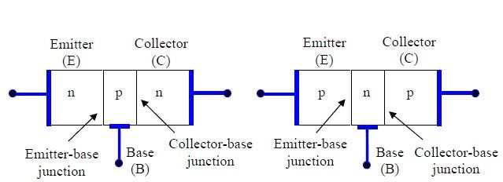

**Circuit Configuration:**

The following figures show the symbol for the npn transistor and pnp transistor. The emitter of the BJT is always marked by an arrow, which indicates whether the transistor is an npn or a pnp transistor.

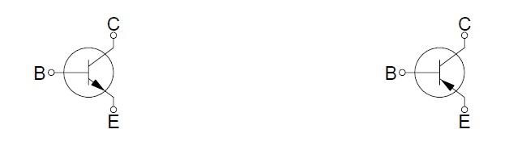

**npn BJT symbol pnp BJT symbol**

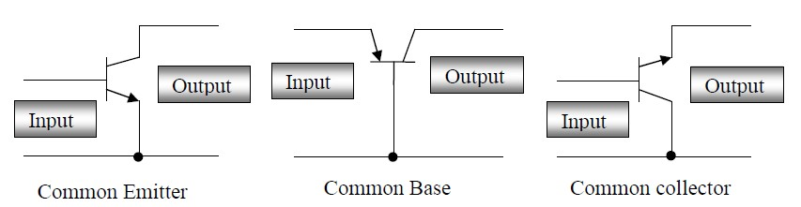

There are three basic ways in which a BJT can be configured. In each case, one terminal is common to both the input and output circuit shown in figure above.

1. The common emitter configuration is used for voltage and current amplification and is the most common configuration for transistor amplifiers.
2. The common collector configuration often called an emitter follower, since its output is taken from the emitter resistor. It is useful as an impedance matching device since its input impedance is much higher than its output impedance.
3. The common base configuration is used for high frequency applications because the base separates the input and output, minimizing oscillations at high frequency. It has a high voltage gain, relatively low input impedance and high output impedance compared to the common collector.

**Biasing of Bipolar Junction Transistors:**

In most of the cases, the BJT is used as an amplifier or switch. In order to perform these functions, the transistor must be correctly biased. Depending on the bias condition (forward or reverse) of each of the BJT junctions, different modes of operation of the BJT are obtained. The three mode are defined as follows:

1. **Active**: Emitter junction is forward biased, collector junction is reverse biased. The BJT operates in the active mode and the BJT can be used as an amplifier.
2. **Saturation**: Both the emitter and collector junctions are forward biased. If the BJT is used as a switch, the saturation mode corresponds to the on state of the BJT.
3. **Cut-off**: Both the emitter and collector junction are reverse biased. If the BJT is used as a switch, the cut-off mode corresponds to the off state of the BJT.

.

|  |  |
| --- | --- |
| **Apparatus:** |  |

|  |  |  |  |
| --- | --- | --- | --- |
| 1. | Trainer Board |  |  |
| 2. | Transistor | C828 | [ 1pc] |
| 3. | Resistors | 1KΩ & 10KΩ | [ 2pc] |
| 4. | DC Power Supply |  |  |
| 5. | Multimeter |  |  |
| 6. | Power Supply Cable |  | [ 2 pc] |

**Experimental Procedure:**

**Circuit Diagram:**

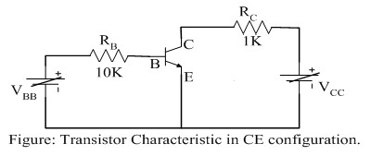

1. The terminals of the transistor were identified.
2. The circuit connections were made as shown in the above figure.
3. For input characteristics the voltage VCE were fixed first and the voltage VBB were varied and the Base current IB were calculated.
4. For output characteristics, the input circuit were opened at first (i. e. to make IB = 0). The collector voltage VCC were varied in steps of 4V and the Collector current IC were calculated.

Now the input circuit was closed and the base current IB was fixed at 50μA by varying VBB. The voltage VCC were varied according to the table and IC were calculated in each step. The process was repeated for other values of IB.

**(4) Simulation Circuits and Results:**

**Simulation Circuit for Input characteristics:**

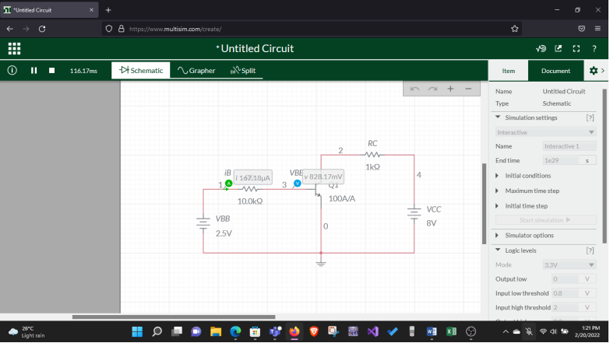

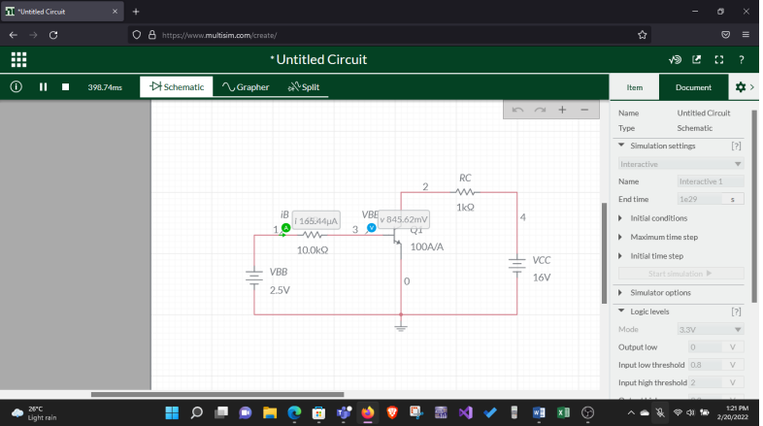

### Input Characteristics

### 

|  |  |  |  |  |  |
| --- | --- | --- | --- | --- | --- |
|  | VCC = 8V |  |  | VCC = 16V | |
| VBB | VBE (V) | IB (uA) | VBB | VBE (V) | IB (uA) |
| 0v | 0 | 0 | 0v | 0 | 0 |
| 0.5v | 0.5 | 0.00024 | 0.5v | 0.5 | 0.00023 |
| 1v | 0.793 | 20.69 | 1v | 0.793 | 20.698 |
| 1.5v | 0.823 | 67.63 | 1.5v | 0.823 | 67.63 |
| 2v | 0.827 | 117.22 | 2v | 0.837 | 116.23 |
| 2.5v | 0.828 | 167.18 | 2.5v | 0.845 | 166.45 |

**Simulation Circuit for Output Characteristics:**

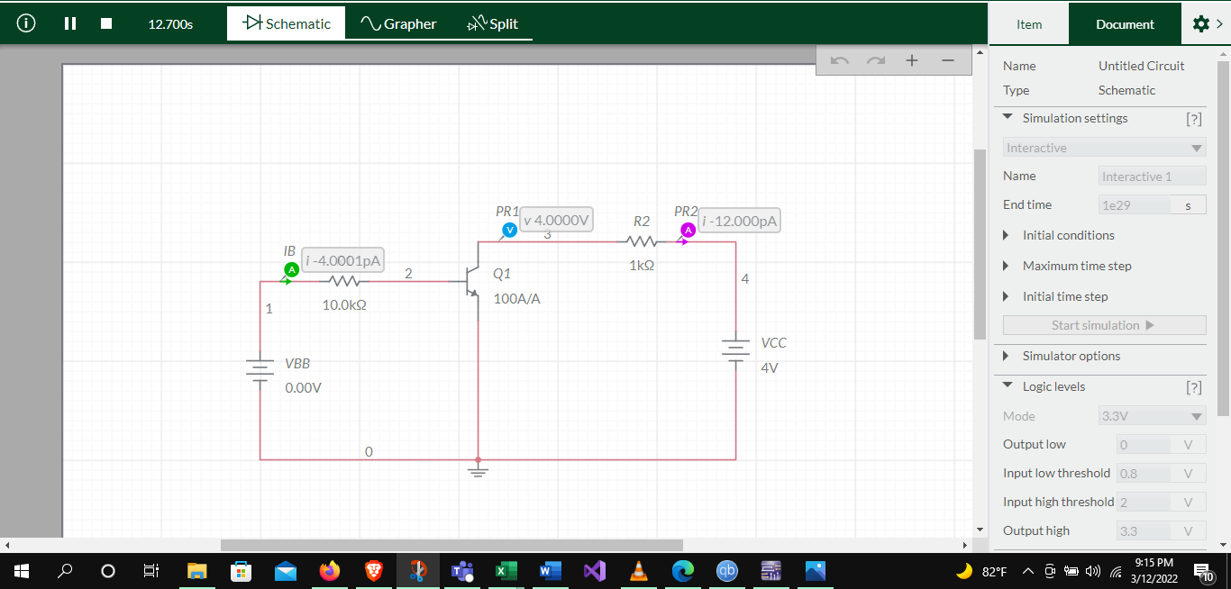

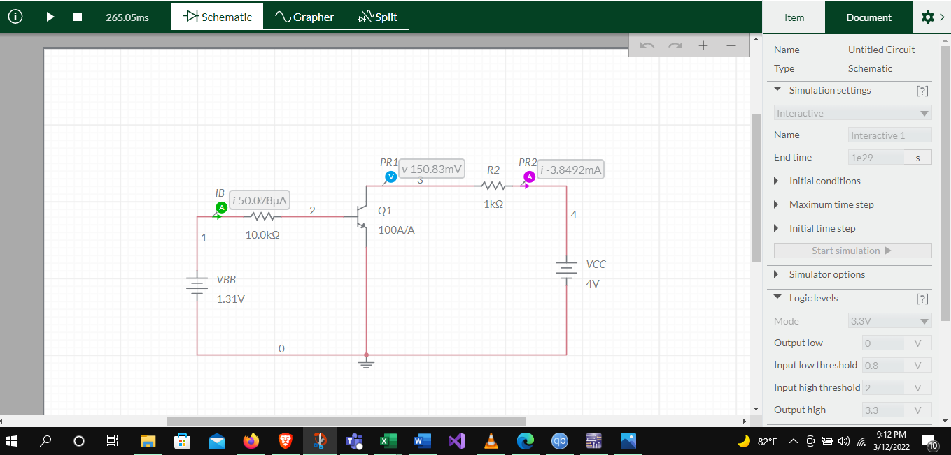

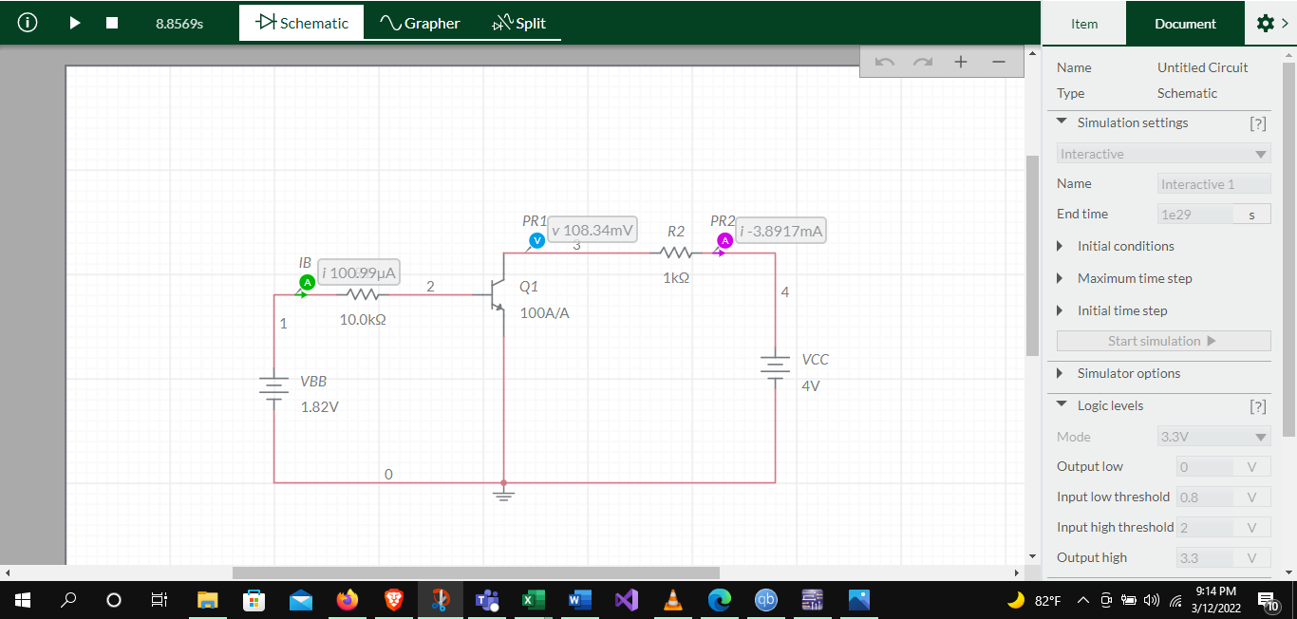

**2. Output Characteristics**

|  |  |  |  |  |  |  |  |  |
| --- | --- | --- | --- | --- | --- | --- | --- | --- |
|  | IB = 0 μA | |  | IB =50 μA | |  | IB = 100 μA | |
| VCC | VCE | IC | VCC | VCE (mV) | IC (mA) | VCC | VCE (mV) | IC (mA) |
| 0v | 0 | 0 | 0v | 0 | 0 | 0v | 0 | 0 |
| 4v | 4 | 0 | 4v | 0.15 | 3.84 | 4v | 0.108 | 3.89 |
| 8v | 8 | 0 | 8v | 2.99 | 5.03 | 8v | 0.152 | 7.84 |
| 12v | 12 | 0 | 12v | 6.96 | 5.03 | 12v | 1.93 | 10.06 |
| 16v | 16 | 0 | 16v | 10.96 | 5.039 | 16v | 5.93 | 10.061 |

**(5) Report Question:**

1. Plot the input {IB vs VBE} and output {IC vs VCE} characteristics as well as {IB vs IC} curves using Excel.

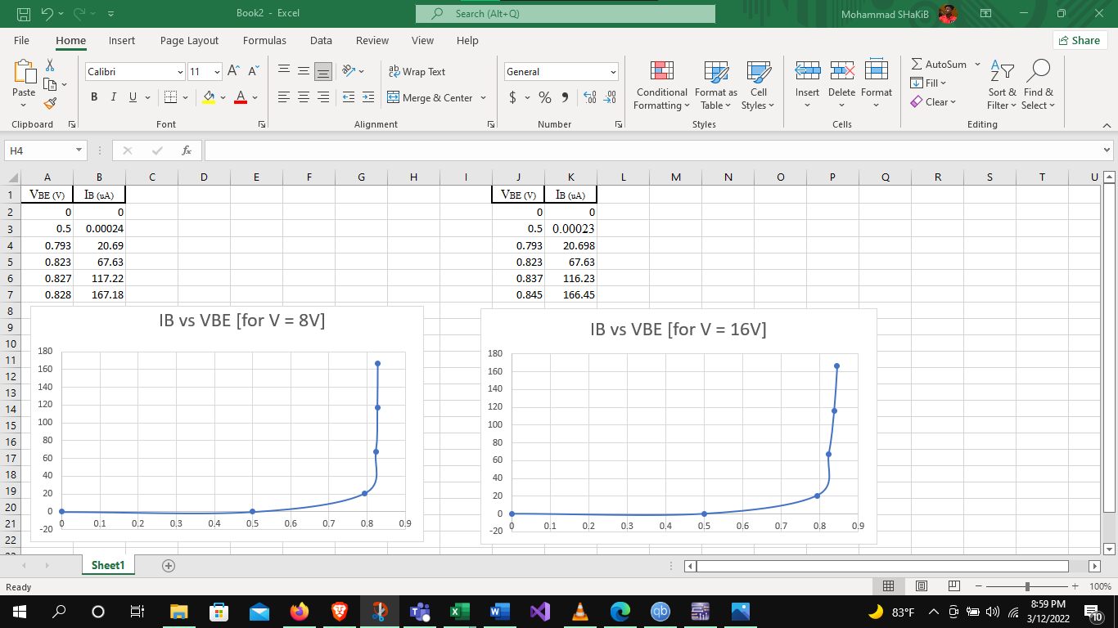

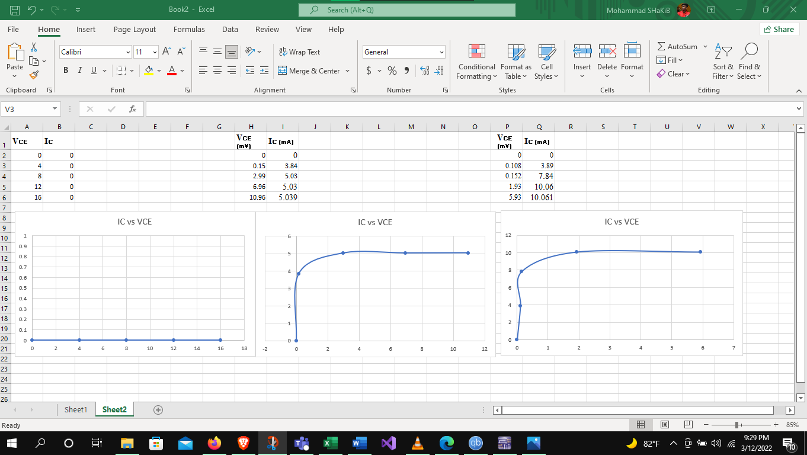

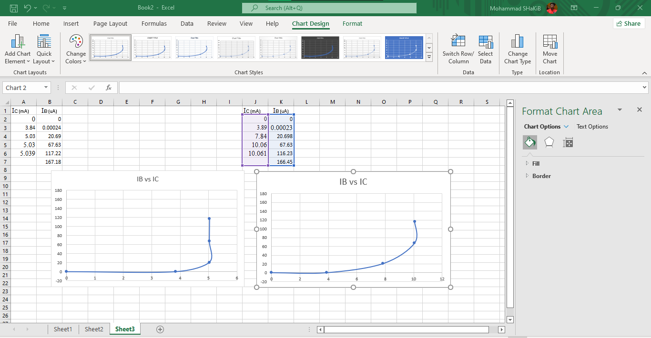

1. Explain the behavior of the input and output characteristics in terms of the three regions of operation: cutoff, active, saturation.

The input characteristics curves are plotted between IB and VBE keeping the voltage, VCE, constant. The input characteristics look like the characteristics of a forward-biased diode. The base-to-emitter voltage varies only slightly. The input dynamic resistance is calculated from the ratio of the small change of base-to-emitter voltage to the small change of base current.

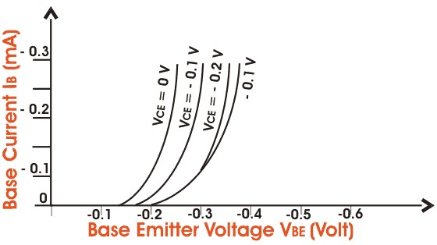

**Fig: BJT Common Emitter Input Characteristics**

The output characteristics curves are plotted between the collector current, IC, and the collector-to-emitter voltage drop by keeping the base current, IB, constant. These curves are almost horizontal. The output dynamic resistance again can be calculated from the ratio of the small change of emitter-to-collector voltage drop to the small change of the collector current.

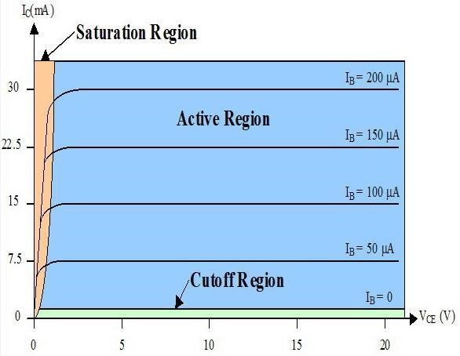

**Fig: BJT Common Emitter Output Characteristics**

1. What is the Q-point?

Q-point is a point on load line and it’s also called bias point and should be in active region. It’s used to determine the operating voltage and current from the transistor characteristics.

**(6) Discussion:**

In this experiment, we became familiar with BJT or bipolar junction transistors. It is a three terminal semiconductor device. Today we used the n-p-n BJT with common emitter configuration which is most commonly used for voltage and current amplification. First of all, we build the circuit according to the circuit diagram. The input characteristics were plotted between IB and voltage drop in base to emitter, VBE keeping the voltage VCE constant for both 8V and 16V. By using multimeter, we got the measurements and filled up table 1 accordingly. And for output characteristics, which were plotted between the collector current, IC and the collector to emitter voltage drop, VCE by keeping the base current, IC constant for both 50 𝜇𝐴and 100 𝜇𝐴. Fixing the base current IB by varying VBB and varying VCC according to table 2, we got the measurements using multimeter. By performing the experiment accordingly, we didn’t face any further problems and finished the experiment successfully.

**(7) References:**

1. Adel S. Sedra, Kennth C. Smith, Microelectronic, Circuits, Saunders College Publishing, 3rd ed., ISBN: 0-03-051648-X, 1991.
2. American International University–Bangladesh (AIUB) Electronic Devices Lab Manual.